Solar powered water motor for mini garden

Puneeth Ram P

Department of Artificial Intelligence and Data Science

R.M.K. Engineering College

[Pune20203.ad@rmkec.ac.in](mailto:Pune20203.ad@rmkec.ac.in)

Ms. T. Jermin Jeaunita Assistant Professor,

Department of

**ABSTRACT:** Solar energy is a renewable energy source. Solar energy is becoming important day by day. It is efficient than other renewable energy sources. This project aims on developing a motor pump for mini garden using solar panel. It also saves the money spent on electricity. It uses solar panels to provide power to the system at daytime. DC motor water pump is connected to solar panel for electricity supply. One end of the DC motor water pump is connected to water. Other end of the water pump is connected to the sprinkler or pipe to water the plants. A led bulb is also connected in series to check for the constant electrical supply. Through this project a simple watering system using solar panel is made.

Keywords: Solar energy ,Solar panel , DC motor, Mini garden

1 . Introduction :

* 1. Problem statement:

A solar-powered pump is a normal pump with an electric motor. Electricity for the motor is generated onsite through a solar panel which converts solar energy to direct-current (DC) electricity. Because the nature of the electrical output from a solar panel is DC, a solar powered pump requires a DC motor if it is to operate without additional electrical components. The man objective of the project is to design a working model of solar powered water motor for watering plants of the Mini garden.

1.2 Objective of the project

Water motor pump are mostly used in agricultural lands for delivering water to the crops. It is common to use fossil fuels like coal to generate electricity. But burning of fossil fuels cause air pollution and lead to global warming and also fossil fuels are being depleted now a days. So we should have an alternative electricity source which should be renewable and also should not cause pollution and Solar energy is the best example for it. The objective of the project is to prepare a working model of water motor for watering mini garden by using solar energy.

1.3 Project Scope:

Renewable energy sources in general, and Solar Energy source in particular, has the potential to provide energy services with zero or almost zero emission. The solar energy is abundant and no other source in renewable energy is like solar energy. The solar-powered pumping system can be used anywhere but it is appropriate for rural areas which is facing energy crisis. In 2011, the International Energy Agency said that “the development of affordable, inexhaustible and clean solar energy technologies will have huge longer-term benefits.”

WATER PUMPING : Water pumping is one of the simplest and most appropriate uses for photovoltaic. From crop irrigation to stock watering to domestic uses, photovoltaic-powered pumping systems meet a broad range of water needs. Most of these systems have the added advantage of storing water for use when the sun is not shining, eliminating the need for batteries, enhancing simplicity and reducing overall system costs. Many people considering installing a solar water pumping system are put off by the expense. Viewing the expense over a period of 10 years, however, gives a better idea of the actual cost. By comparing installation costs (including labour), fuel costs, and maintenance costs over 10 years, you may find that solar is an economical choice. A solar-powered pumping system is generally in the same price range as a new windmill but tends to be more reliable and require less maintenance. A solar-powered pumping system generally costs more initially than a gas, diesel, or propane-powered generator but again requires far less maintenance and labour.

Solar-Powered Water Pumping System Configurations : There are two basic types of solar-powered water pumping systems, battery-coupled and direct-coupled. A variety of factors must be considered in determining the optimum system for a particular application [1] Battery-coupled water pumping systems consist of photovoltaic (PV) panels, charge control regulator, batteries, pump controller, pressure switch and tank and DC water pump (Figure 3). The electric current produced by PV panels during daylight hours charges the batteries, and the batteries in turn supply power to the pump anytime water is needed. The use of batteries spreads the pumping over a longer period of time by providing a steady operating voltage to the DC motor of the pump. Thus, during the night and low light periods, the system can still deliver a constant source of water for livestock. The use of batteries has its drawbacks. First, batteries can reduce the efficiency of the overall system because the operating voltage is dictated by the batteries and not the PV panels. Depending on their temperature and how well the batteries are charged, the voltage supplied by the batteries can be one to four volts lower than the voltage produced by the panels during maximum sunlight conditions. This reduced efficiency can be minimized with the use of an appropriate pump controller that boosts the battery voltage supplied to the pump. n direct-coupled pumping systems, electricity from the PV modules is sent directly to the pump, which in turn

pumps water through a pipe to where it is needed (Figure 4). This system is designed to pump water only during the day. The amount of water pumped is totally dependent on the amount of sunlight hitting the PV panels and the type of pump. Because the intensity of the sun and the angle at which it strikes the PV panel changes throughout the day, the amount of water pumped by this system also changes throughout the day. For instance, during optimum sunlight periods (late morning to late afternoon on bright sunny days) the pump operates at or near 100 percent efficiency with maximum water flow. However, during early morning and late afternoon, pump efficiency may drop by as much as 25 percent or more under these low-light conditions. During cloudy days, pump efficiency will drop off even more. To compensate for these variable flow rates, a good match between the pump and PV module(s) is necessary to achieve efficient operation of the system. Direct-coupled pumping systems are sized to store extra water on sunny days so it is available on cloudy days and at night. Water can be stored in a larger-than-needed watering tank or in a separate storage tank and then gravity-fed to smaller watering tanks. Water-storage capacity is important in this pumping system. Two to five days’ storage may be required, depending on climate and pattern of water usage. Storing water in tanks has its drawbacks. Considerable evaporation losses can occur if the water is stored in open tanks, while closed tanks big enough to store several days water supply can be expensive. Also, water in the storage tank may freeze during cold weather.

Main solar powered stock watering system components : A typical solar-powered stock watering system includes a solar array, pump, storage tank and controller .

Solar Modules : Solar electric systems are sometimes called photovoltaic systems. The word “photovoltaic” is often abbreviated PV. Most solar panels, or modules, generate direct current (DC) electricity. A group of modules is called an array.

Pumps : DC water pumps in general use one-third to one-half the energy of conventional AC (alternating current) pumps. DC pumps are classed as either displacement or centrifugal, and can be either submersible or surface types. Displacement pumps use diaphragms, vanes or pistons to seal water in a chamber and force it through a discharge outlet. Centrifugal pumps use a spinning impeller that adds energy to the water and pushes into the system, similar to a water wheel. Submersible pumps, placed down a well or sump, are highly reliable because they are not exposed to freezing temperatures, do not need special protection from the elements, and do not require priming. Surface pumps, located at or near the water surface, are used primarily for moving water through a pipeline. Some surface pumps can develop high heads and are suitable for moving water long distances or to high elevations.

3.METHODOLOGY

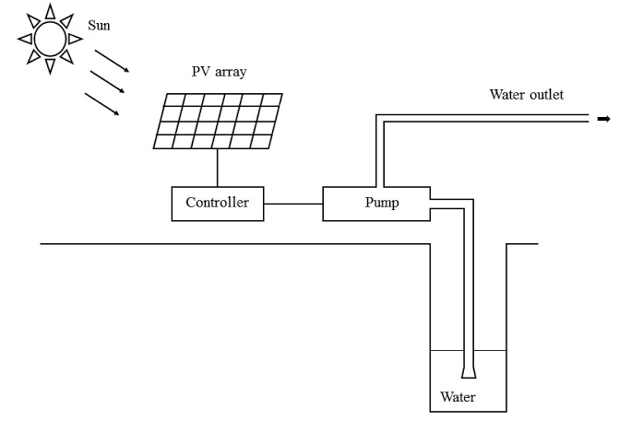

The Project setup is made as same as the above diagram. The DC motor and a LED bulb is connected parallel to the cathode and anode of the solar panel. A key is connected in series. The DC water motor is immersed in the water storage bowl or DC motor can also be connected through a pipe to the water storage.

4. IMPLEMENTATION AND RESULTS

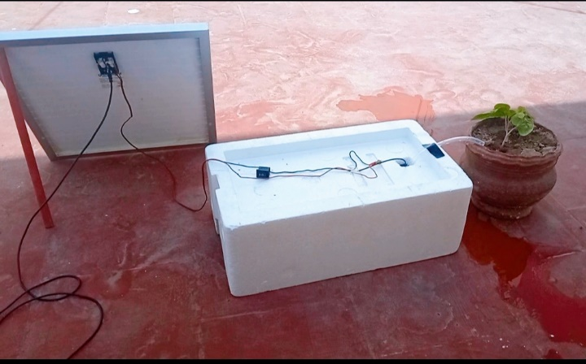

The exact setup is made as shown in the picture. DC motor immersed in the water bowl is kept under the thermocol box. As we are not using a universal solar panel the connecting wires are soldered to the cathode and anode of the solar panel. Also if we want to deliver the water to more than one plant then it can be done by connecting more pipes or a sprinkler at the end of the water outlet pipe.

RESULT

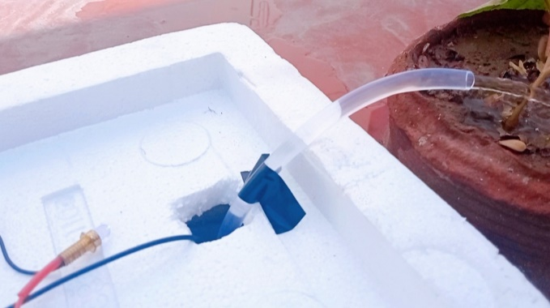

Now when the switch is closed you can notice that the water is coming out of the outlet and also we can see that LED bulb also glows. As mentioned earlier LED bulb is connected for reference. So finally the setup is made as a complete working model.

5. CONCLUSION AND FUTURE ENHANCEMENT

This project can be used in large scale for example in agricultural areas. As we all know the fossil fuels are depleting these days. Under the circumstances of inadequate supply of electrical energy, the solar water pump can play a significant role. Solar photovoltaic pumping offers an alternate means to meet the electricity demand for irrigation and livestock watering. The proposed solar water pumping system has long lifetime and it is maintenance free. Since the increase in price per increase in unit power output of a photovoltaic system is greater than that for a diesel, gasoline, or electric system, photovoltaic power is more cost competitive when the irrigation system with which it operates has a low total dynamic head. If the total system design and utilization timing is carefully considered and organized to use the solar energy as efficiently as possible. In the future, when the prices of fossil fuels rise and the economic advantages of mass production reduce the peak watt cost of the photovoltaic cell, photovoltaic power will become more cost-competitive and more common.

6. REFERENCES

|  |  |
| --- | --- |
| 1. | Bulent Eker, “Solar powered water pumping system” ,Trakia Journal of Sciences, Vol. 3, No. 7, pp 7-11, 2005. |
| 2. | Balkeshwar Singh & Anil Kumar Mishra, “ Utilization of Solar Energy for Driving a Water Pumping System”, International Research Journal of Engineering and Technology (IRJET), Volume: 02 Issue: 03 | June-2015. |